
Wine Quality Classification Dataset
The dataset, which can be found in https://archive.ics.uci.edu/dataset/186/wine+quality, includes red and white variants of the Portuguese Vinho Verde wine. It contains 11 physicochemical attributes (such as acidity, sugar, pH) as inputs, and a sensory quality score as the output. The data does not include private or brand-specific information (e.g., grape type, price, or brand name). The main task is a binary classification problem, aiming to categorize each wine as good (quality ≥ 7) = G or bad (quality < 7) = B. The original dataset includes a numerical quality score which was transformed into a categorical score in Microsoft Excel, with the addition of the column “binary_quality”. The dataset is imbalanced, with significantly more “average” wines than excellent or poor ones.
Isalos version used: 2.0.6

Step 1: Import data from file
Right click on the input spreadsheet (left) and choose the option “Import from File”. Then navigate through your files to load the one with the wine quality data.
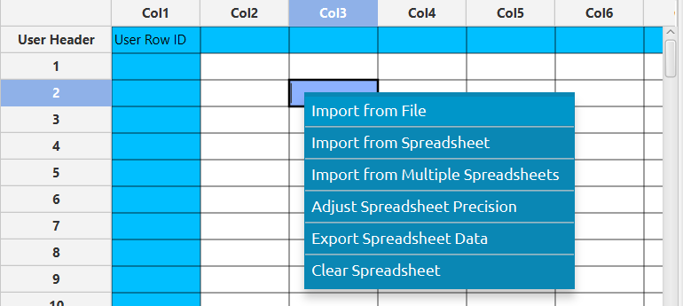

The data will appear on the left spreadsheet.
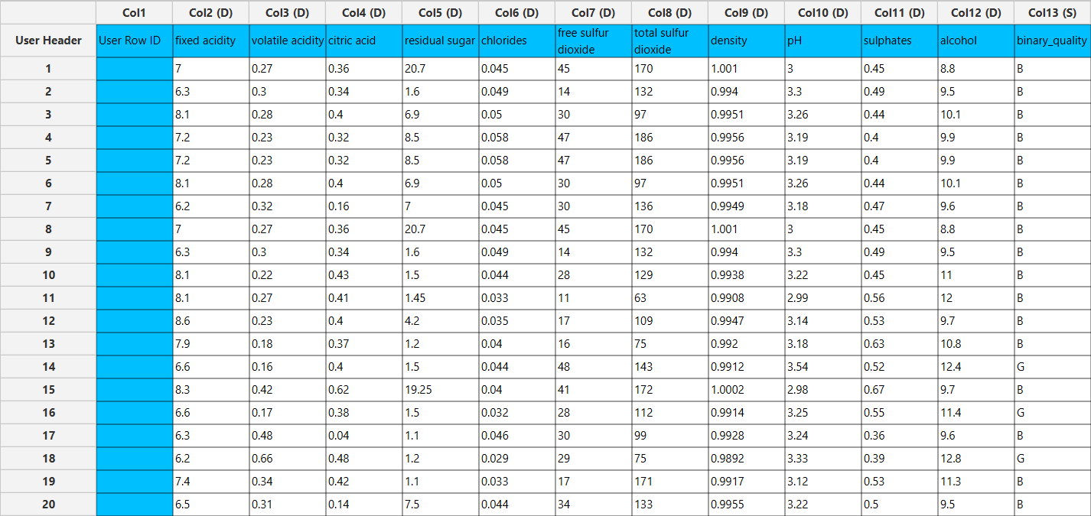

Step 2: Manipulate data
In our dataset there are not any empty values, so we can select all the columns to be used. On the menu click on Data Transformation $→$ Data Manipulation $→$ Select Column(s) and select all columns, except the column “quality”, which is the numerical quality score.
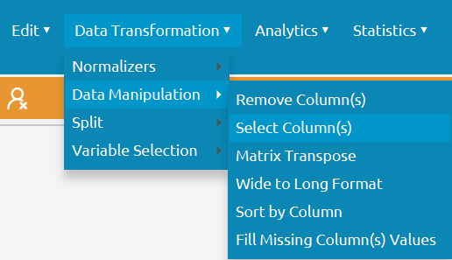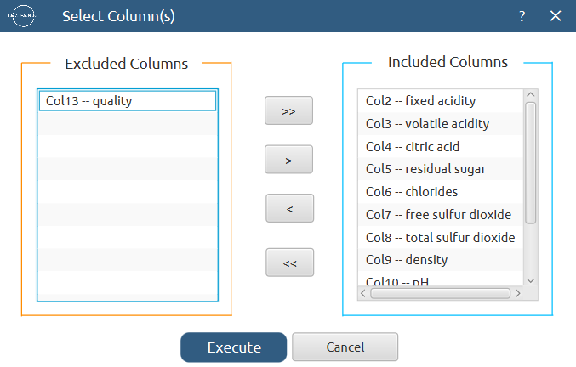

All of the data will appear in the output (right) spreadsheet. This tab can be renamed “IMPORT” by right-clicking on it and choosing the “Rename” option.

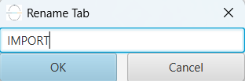

Step 3: Split data
Create a new tab by pressing the “+” button on the bottom of the page with the name “TRAIN_TEST_SPLIT” which we will use for splitting the train and test set.
Import data into the input spreadsheet of the “TRAIN_TEST_SPLIT” tab from the output of the “IMPORT” tab by right-clicking on the input spreadsheet and then choosing “Import from Spreadsheet”.



Split the dataset by choosing Data Transformation $→$ Split $→$ Random Partitioning. Then choose the “Training set percentage” and the column for the sampling as shown below:
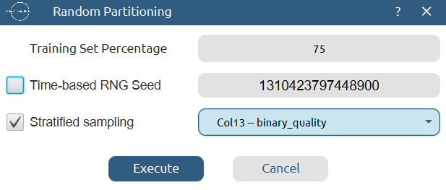

The results will be two separate spreadsheets, “TRAIN_TEST_SPLIT: Training Set” and “TRAIN_TEST_SPLIT: Test Set”, which will be available to import into the next tabs.

Step 4: Normalize the training set
Create a new tab by pressing the “+” button on the bottom of the page with the name “NORMALIZE_TRAIN_SET”.
Import into the input spreadsheet of the “NORMALIZE_TRAIN_SET” tab the train set from the output of the “TRAIN_TEST_SPLIT” tab by right-clicking on the input spreadsheet and then choosing “Import from Spreadsheet”. From the available Select input tab options choose “TRAIN_TEST_SPLIT: Training Set”.
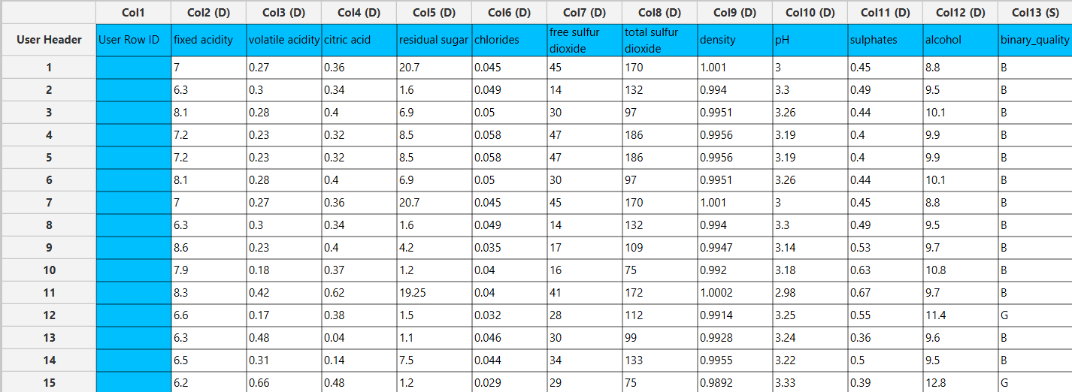

Normalize the data using Z-score: Data Transformation $→$ Normalizers $→$ Z Score and select all columns.
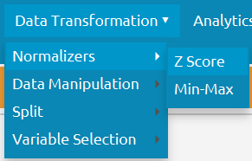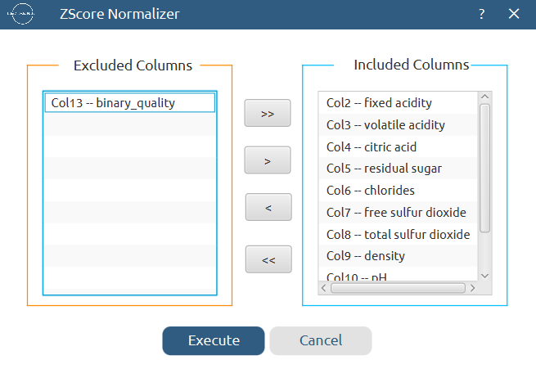

The results will appear on the output spreadsheet.
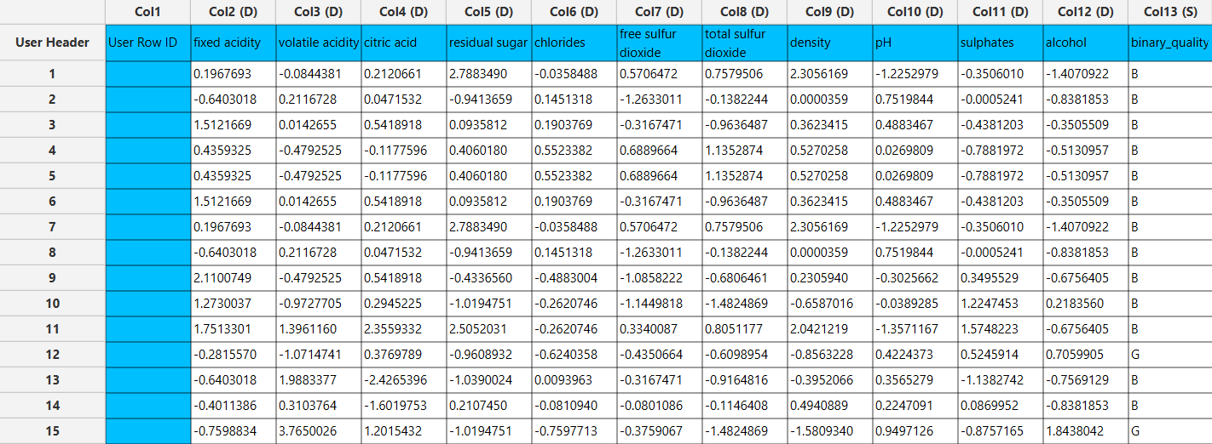

Step 5: Normalize the test set
Create a new tab by pressing the “+” button on the bottom of the page with the name “NORMALIZE_TEST_SET”.
Import into the input spreadsheet of the “NORMALIZE_TEST_SET” tab the test set from the output of the “TRAIN_TEST_SPLIT” tab by right-clicking on the input spreadsheet and then choosing “Import from Spreadsheet”. From the available Select input tab options choose “TRAIN_TEST_SPLIT: Test Set”.
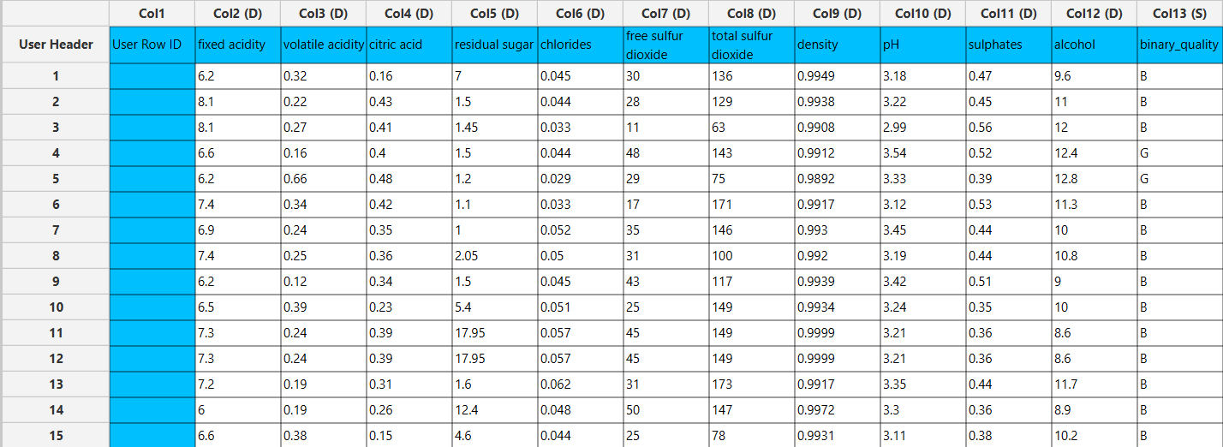

Normalize the test set using the existing normalizer of the training set: Analytics $→$ Existing Model Utilization $→$ Model (from Tab:) NORMALIZE_TRAIN_SET
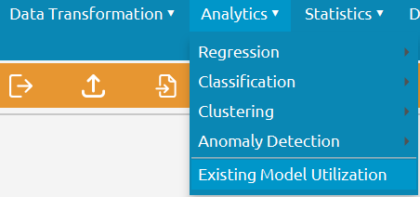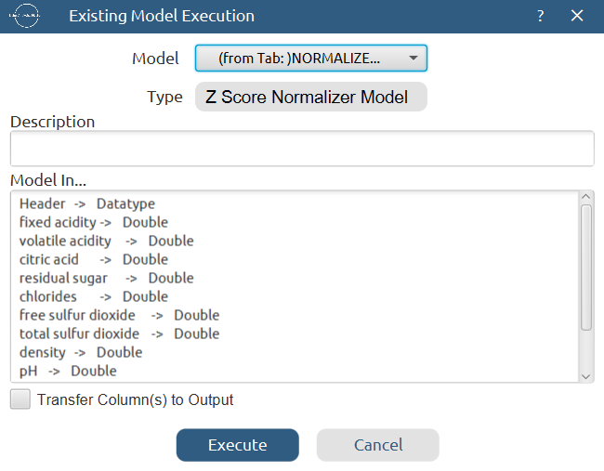

The results will appear on the output spreadsheet.
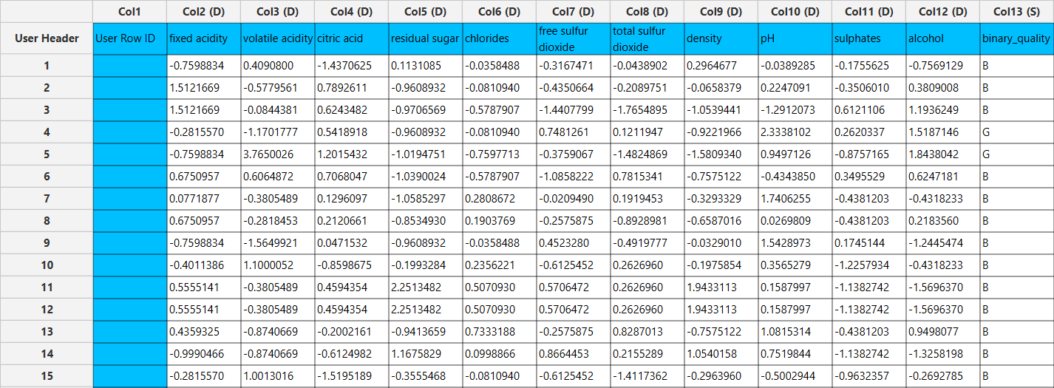

Step 6: Train the model
Create a new tab by pressing the “+” button on the bottom of the page with the name “TRAIN_MODEL(.fit)”.
Import data into the input spreadsheet of the “TRAIN_MODEL(.fit)” tab from the output of the “NORMALIZE_TRAIN_SET” tab by right-clicking on the input spreadsheet and then choosing “Import from Spreadsheet”.
Use the Random Forest method to train and fit the model: Analytics $→$ Classification $→$ Random Forest
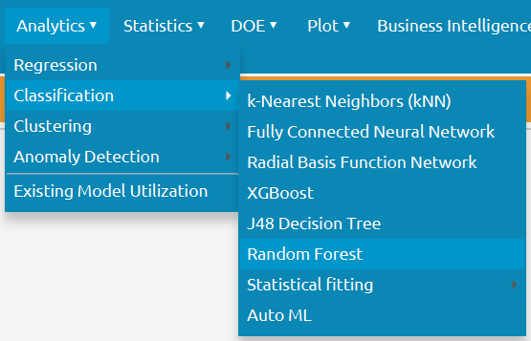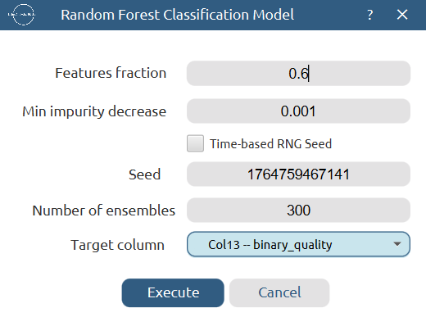

The predictions will appear on the output spreadsheet.
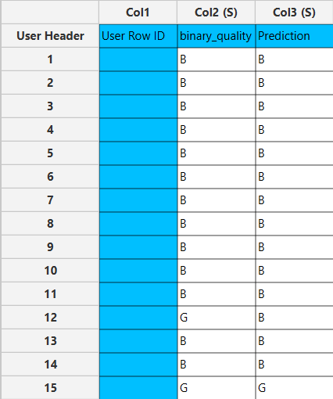

Step 7: Validate the model
Create a new tab by pressing the “+” button on the bottom of the page with the name “VALIDATE_MODEL(.predict)”.
Import data into the input spreadsheet of the “VALIDATE_MODEL(.predict)” tab from the output of the “NORMALIZE_TEST_SET” tab by right-clicking on the input spreadsheet and then choosing “Import from Spreadsheet”.
To validate the model: Analytics $→$ Existing Model Utilization$→$ Model (from Tab:) TRAIN_MODEL(.fit). Choose the column “binary_quality” to be transferred to the output spreadsheet.
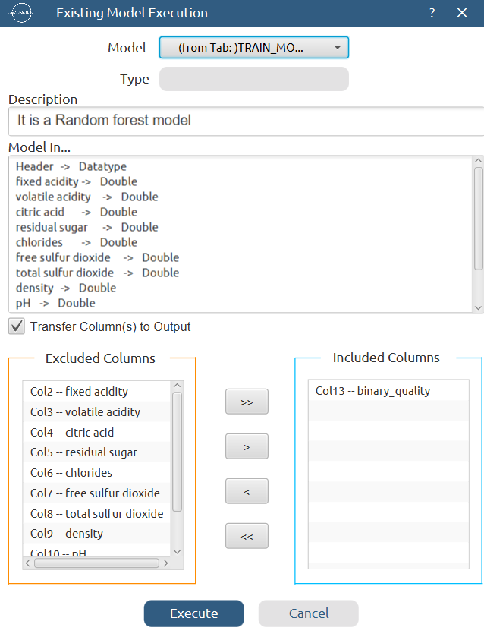

The predictions will appear on the output spreadsheet.
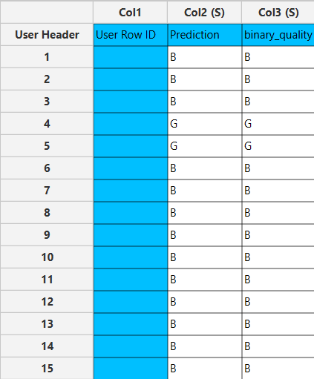

Step 8: Statistics calculation
Create a new tab by pressing the “+” button on the bottom of the page with the name “STATISTICS_ACCURACIES”.
Import data into the input spreadsheet of the “STATISTICS_ACCURACIES” tab from the output of the “VALIDATE_MODEL(.predict)” tab by right-clicking on the input spreadsheet and then choosing “Import from Spreadsheet”.
Calculate the statistical metrics for the classification: Statistics $→$ Model Metrics $→$ Classification Metrics
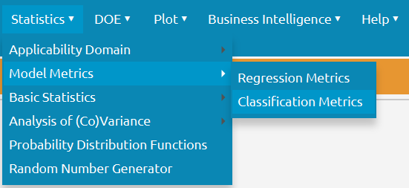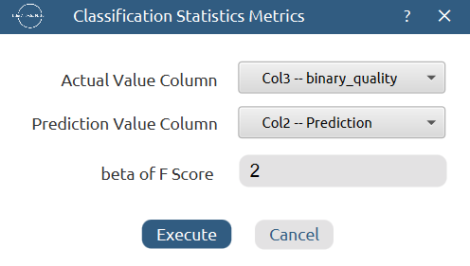

The results will appear on the output spreadsheet.
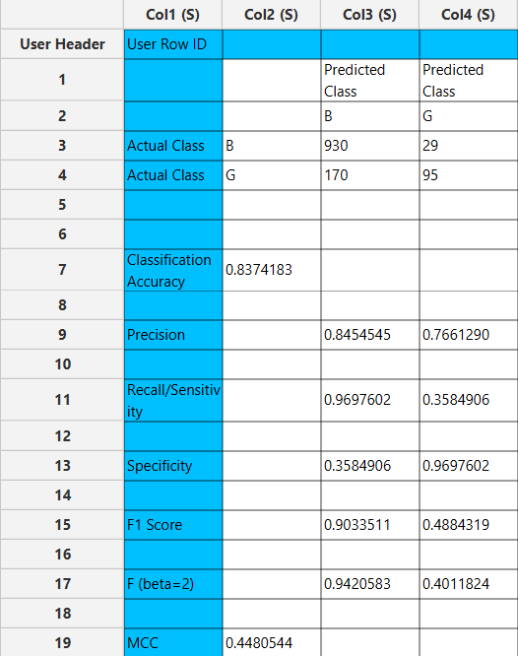

Step 9: Reliability check for each record of the test set

Step 9.a: Create the domain
Create a new tab by pressing the “+” button on the bottom of the page with the name “DOMAIN”.
Import data into the input spreadsheet of the “DOMAIN” tab from the output of the “NORMALIZE_TRAIN_SET” tab by right-clicking on the input spreadsheet and then choosing “Import from Spreadsheet”.
Create the domain: Statistics $→$ Applicability Domain $→$ APD
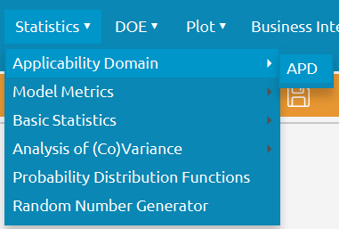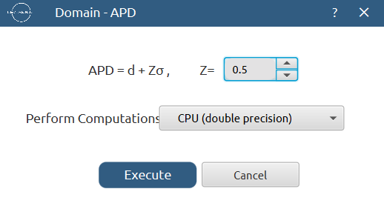

The results will appear on the output spreadsheet.
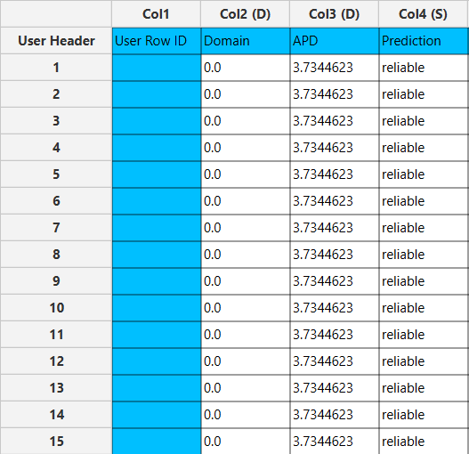

Step 9.b: Check the test set reliability
Create a new tab by pressing the “+” button on the bottom of the page with the name “RELIABILITY”.
Import data into the input spreadsheet of the “RELIABILITY” tab from the output of the “NORMALIZE_TEST_SET” tab by right-clicking on the input spreadsheet and then choosing “Import from Spreadsheet”.
Check the Reliability: Analytics $→$ Existing Model Utilization$→$ Model (from Tab:) DOMAIN
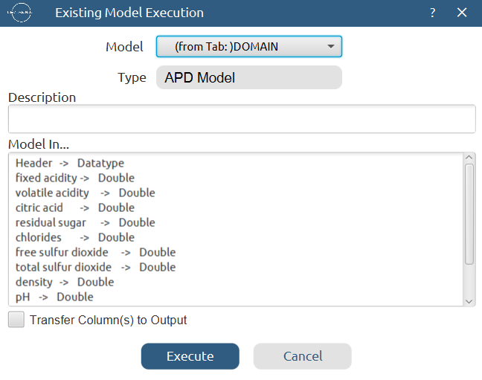

The results will appear on the output spreadsheet.
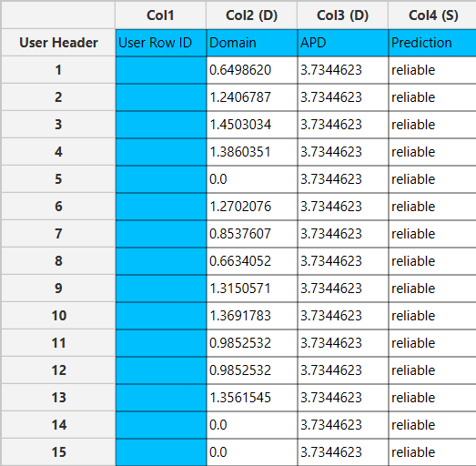

Final Isalos Workflow
Following the above-described steps, the final workflow on Isalos will look like this:
